**Part 1: Number systems:**

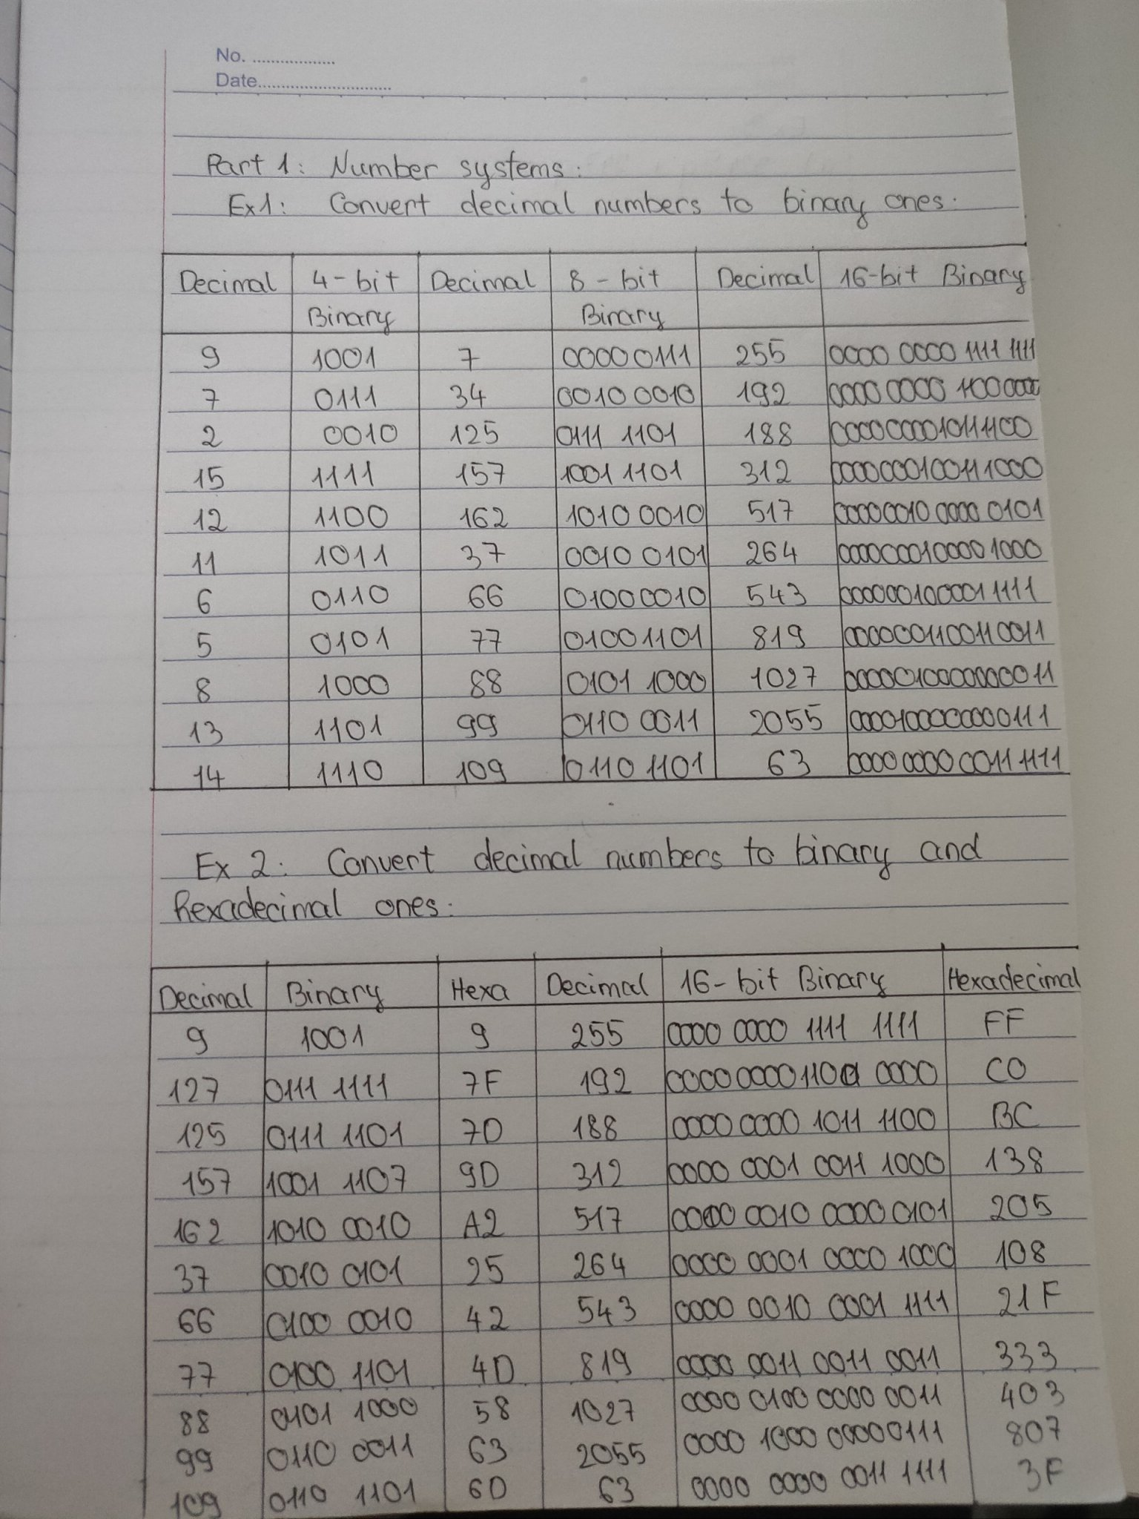

**Exercise 3 (2 marks): Compute**

**(b: binary, q: octal, h: hexadecimal**)

**3245q + 247q = ?q = ?b** = 3514q = 011101001100b

**1A7Bh + 26FE7h = ?h = ?b** = 28A62h = 00101000101001100010b

**1101101101b - 10110111b =?b** = 0011111110b

**3654q – 337q =?q = ?b** = 3315q = 011011001101b

**3AB7h – 1FAh = ?h =?b** = 38BDh = 0011100010111101b

**36Ah – 576q = ? h = ?b** = 1Ech = 000111101100b

**64AEh – 1001101b= ?q** = 62141q

**101101111 b**

**+ 100111011 b**

**110110001 b**

**110001101 b**

110010110 b

**1011010 b* 1011b** = 1111011110b

**1101000b + 2AB h + 345 q** = ? h = ? q = 3Deh= 1736q

**3AFh / 1Ch =? b = ?d** = 00100001b = 33d

**3ACh – 562q = ?b = ? d** = 001000111010b = 570d

**3FFA h / 327q = ?b = ? d** = 01001100b = 76d

**Exercise 4 (2 marks)**

1. Show binary formats of 1-byte unsigned numbers:

**251**: 11111011

**163**: 10100011

**117**: 01110101

1. Show binary formats of 2-byte unsigned numbers:

**551**: 0000001000100111

**160**: 0000000010100000

**443**: 0000000110111011

1. Show binary formats of 1-byte signed numbers:

**-51**: 1 00110011 ,

**-163**: 1 10100011,

**-117**: 1 01110101,

**-20**: 1 00010100

1. Show the decimal values of 1-byte unsigned representations: :

**01100011 b**: 99

**10001111 b**: 143 ,

**11001010 b**: 202 ,

**01001100 b**: 76

**Part 2: Explore memory structure of programs:**

